cv

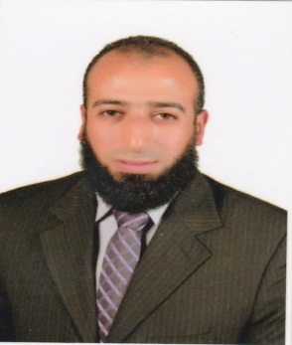
Personal information:
Name |  | Nationality | Date of birth | Age | Place of birth
Ahmed Taha Mahmoud Ali |  | Egyptian | 13/9/1984 | 36 | Qalyubia
Home | Qalyubia - Banha - Al-Feel neighborhood, 11th Street, Villa 177
mobile number | 01009083139 | E-mail | ahmed.ali01@fped.bu.edu.eg
Job | Teacher doctor | The entity | College of Physical Education for Boys - Benha University
Academic qualifications and certificates obtained:
م | Qualification | Date | University / Institute | College / Center
1- | Bachelor of Sports Education | 2005 | Banha university | physical education
2- | MA in Mathematical Education | 2010 | Banha university | physical education
3- | Doctor of Philosophy | 2015 | Banha university | physical education
: career
1- He works as a teaching assistant at the College of Physical Education for Boys - Benha University, on 12/13/200.
2-He works as an assistant teacher at the College of Physical Education for Boys - Benha University, from 2010 .
3- He works as a professor at the College of Physical Education for Boys - Benha University, from 2015

